David lee

Profile
Well organized, creative, and proven marketing professional. Experience working with and across sales teams and well as external clients and agencies on creative, editorial, strategic, and tactical levels.

CONTACT
PHONE: (716) 555-0100
LINKEDIN: www.linkedin.com/in/lee.david
EMAIL: lee.david@live.com

SKILLS
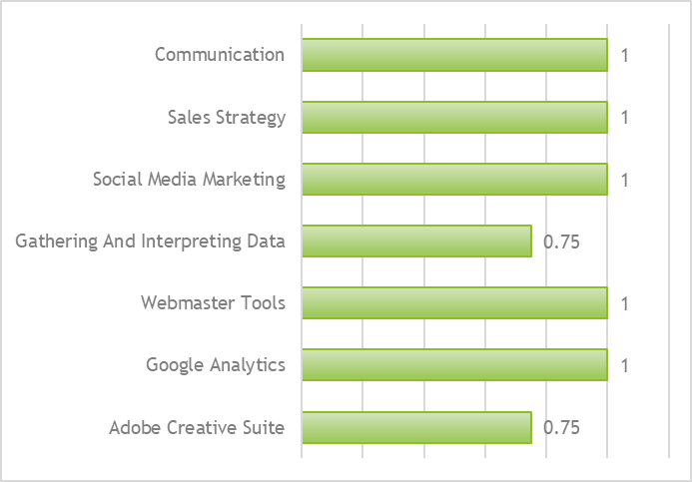

WORK EXPERIENCE

MARKETING CONSULTANT
VANARSDEL LTD, SNIPTOWN, MASSACHUSETTS
SEPTEMBER 2016–PRESENT
- Work with international clients to craft the messaging and implement strategic positioning in their market.
- Assist international clients with business plan, branding, advertising, remodeling, and marketing.
- Over a ten-month period, these efforts boosted monthly sales from $8,000 to $25,000.
- Devised and implemented social media campaign that increased brand awareness by 125% on average. Program resulted in a dramatic $50,000 increase in internet sales.
- Create marketing campaigns including email, print, digital, outdoor, and social media.
- Based on market analysis, craft concept and content for journal ads, direct mail campaigns and blogs.

MARKETING SPECIALIST
LUCERNE PUBLISHING
JUNE 2013–AUGUST 2016
Developed SEO optimized content for numerous in-house websites, blog posts and social media platforms. Several of my international articles were picked up by major media outlets.
Kept current with marketing strategies and developed social media campaigns to increase brand influence.

EDUCATION
Bachelor of arts in Art and Design
School of Fine Art, Mopton, MAssachusetts
2009—2013

